Intro to Unreal Engine - Part Four
  - Locks, Keys, and Conditional Branches

Overview
We have created jumping challenges, moving platforms, collectibles, power-ups, and now it’s time to introduce the final challenge. The secret to completing the game is hidden behind a locked door in a fortress located high up in the sky.
You’ll be using the Blueprint visual scripting system to create the secret key and hide it in your world. Armed with the Blueprints you’ve already created; the floating islands, collectible coins, jump boost power-ups, and a secret key, you’ll be able to test your skills at game design. When the player finds the key, unlocks the door, and reaches the end goal, they’ll see their score.
At the end of this activity, you’ll be able to play your game from beginning to end.
Please alert your instructor if you come across instructions or screenshots that need to be updated for Unreal Engine 5.

Learning Outcomes
By the end of this module, you should be able to:
- Explain how conditional statements work with Boolean conditions in Blueprint code.
- Create new Actor assets that include Static Mesh and Collision components.
- Add custom Blueprint code to an asset that involves:
  - Event Triggers
  - Game Mode Communication
  - Variable Assignment
  - Playing Sounds
  - Destroying an Actor

Let’s Play
If you play the game and reach the door to the large building, you will notice that you require a key to open it. (Figure 001)
Let’s start the game at the door so you can test it out. Click in the Viewport and press the number 5 key to move to the camera 5 bookmark. Make sure the Current Camera Location option is selected in the Play button options and then press Play.
Walk up to the door. You should be able to open the door once you are in front of it by pressing the letter E.
Stop your gameplay here so we can get into the editor. We’re going to add a lock to this door that can only be opened after the player finds the key.
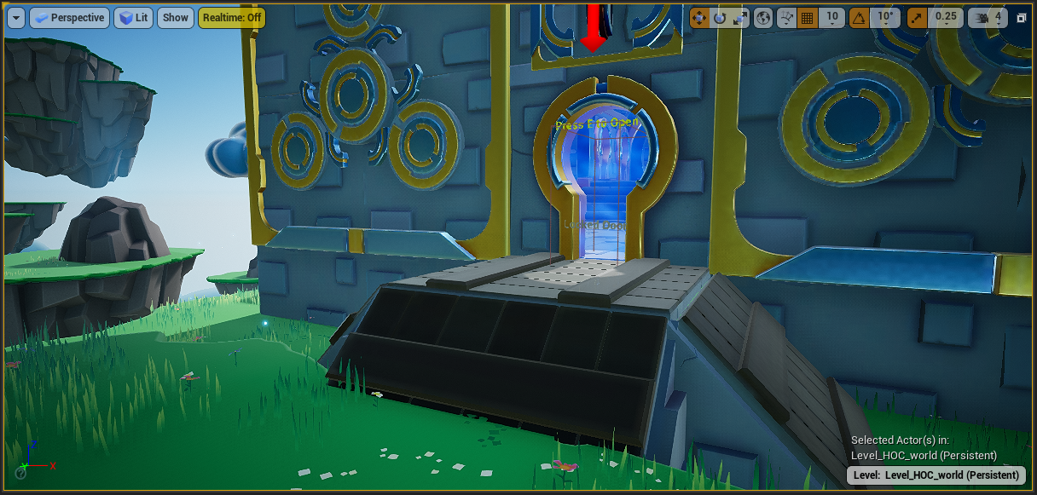
Figure 001 – This Door Requires A Key

Conditional Statements
A conditional statement checks to see if something is true or false. More commonly they are called if/then statements and they are also known as if/then/else statements.
Our work in this activity will involve conditionally opening a door if the player has a key:
- If the key has been picked up => True (Open the Door)
- If the key has not been picked up => False (Do Not Open the Door)
In Blueprint this type of decision is also known as a Branch. The branch’s output is determined by a Boolean condition. The branch node looks like this (Figure 002):
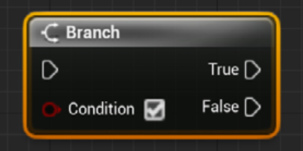
Figure 002 – Blueprint Branch node with Boolean Condition as Input
🤖 TECHNICAL JARGON DEFINED
Boolean: In Programming, a condition can be stored as a Boolean, or bool for short. The data can be stored in one of two states, it is either ON (true) or OFF (false). Bools are red, making them easy to see at a glance in your Blueprints.
Later in this activity we’ll be interacting with a Boolean condition called “Have Key?” (Figure 003) which will be true is the player has the key and false if they do not.
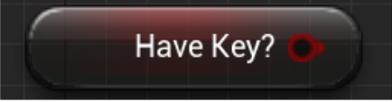
Figure 003 – The Boolean used to represent whether or not the player has the key.

Blueprint Scripting
The main thing we will be doing in this level is building the “key” Blueprint. You can think of a Blueprint as a suitcase that contains objects as well as code, and that code can talk with various parts of your game.
For example, your suitcase can contain your cell phone, and your cell phone can talk with a GPS satellite. This would be super handy if the airline lost your suitcase because you can use the code from the GPS to talk to your cell phone and find your suitcase. Which, as it turns out, landed before you did, and is on the baggage carousel behind you.
Although we explored some Blueprints in the previous activities, we haven’t coded one from scratch before. This activity has many steps, each of which must be implemented without error for everything to work. Think about what we are trying to accomplish and follow each step closely to understand how we are building our solution.

Lock the Door
At the start of this activity you were able to open the door on the final island. The code needed to lock this door is nearly complete, we just need to hook up two Boolean conditions.
Navigate to the Content > Hour_of_Code > Blueprints folder in the Content Browser and open BP_Door by double-clicking on it. In the Event Graph tab, you will see some pre-written Blueprint code (Figure 004). Take a moment to look over the code while paying close attention to the color-coded comments.
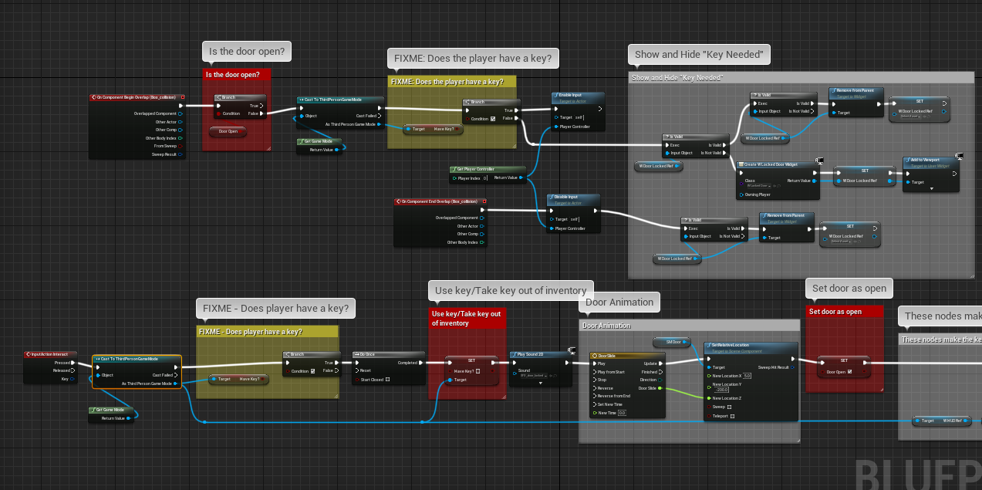
Figure 004 – The Event Graph of the BP_Door blueprint.
🤖 TECHNICAL JARGON DEFINED
Comments: In Programming, a comment is a message left in the code for the future human readers of the code. Code comments are ignored by the computer when executing a Blueprint script.
In the BP_Door Blueprint you will see two yellow comment blocks that start with “FIXME”. These commented areas both contain a Branch node where the condition is permanently set to true with a checkmark (Figure 005). When this condition is permanently set to true the door always opens.
Let’s make the Branch conditions depend on whether the player has a key or not.
With Blueprints, you can click and drag to connect nodes when building your code. Try it now!
Inside these yellow areas simply drag a wire from the Have Key? Boolean pin to the Branch Condition pin (Figure 005). Make sure you do this in both yellow “FIXME” areas.
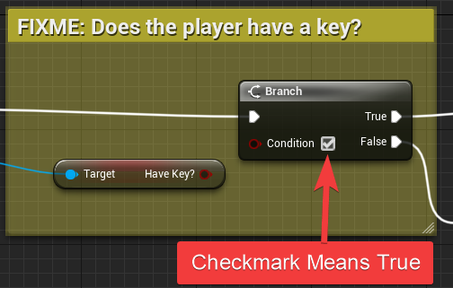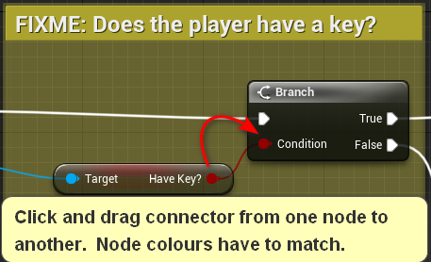
Figure 005 – Connect the “Have Key?” Boolean to the Branch Condition
The Branch nodes will now check the condition “Does the player have a key?” (the haveKey variable). This variable can be either True or False.
Click the Compile and Save buttons above the Event Graph (Figure 006). Compiling converts your changes into executable code, while saving writes these changes to disk. Then return to the main level editor Viewport and click Play (from Current Camera Position). Try walking up to the door. You should no longer be able to get in when pressing the E key.
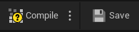
Figure 006 – Compile and Save Buttons

Building the Key
Let’s create a key from scratch that will open the door. First, we’ll create the key’s geometry, and second, we’ll create blueprints that will indicate to the game that the key has been found.
- To build a Blueprint Actor from scratch navigate to Content > Hour_of_Code > Blueprints folder, and right-click in an empty space. Then choose Blueprint Class (Figure 007).
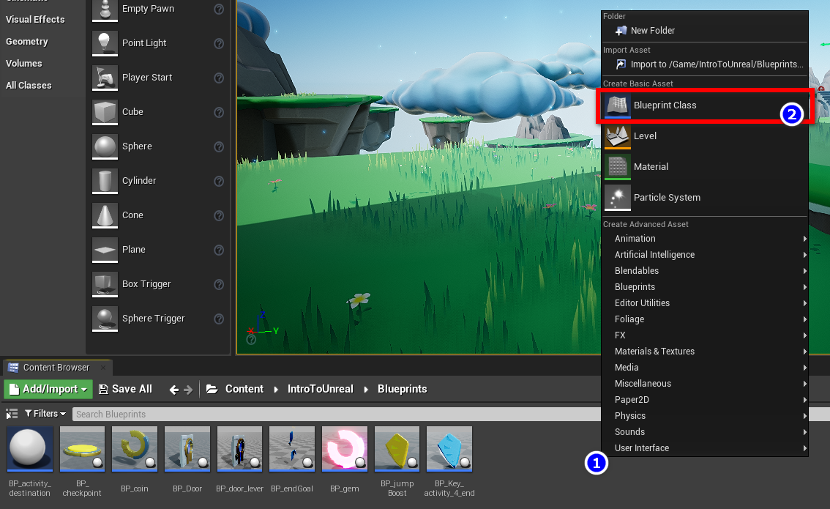
Figure 007 – Right-click the Blueprints area to create a new Blueprint class.
- Select an Actor class from the top of the list (Figure 008).
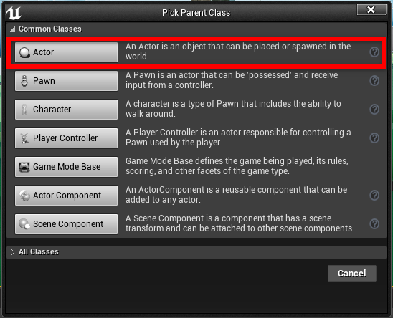
Figure 008 – Select “Actor” as the Blueprint parent class.
- Name this new Blueprint BP_key (Figure 009). (Right click if you need to rename the Blueprint.)
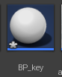s
Figure 009 – Your new key Blueprint.
- Double-click BP_key to open the Blueprint. Click the Viewport tab if it doesn’t automatically load (Figure 010). From here, we will be assembling the parts the player will be able to see and interact with. We will need to add a few Components to the viewport, so the player knows what they will be picking up, and so the Character has something to interact with.
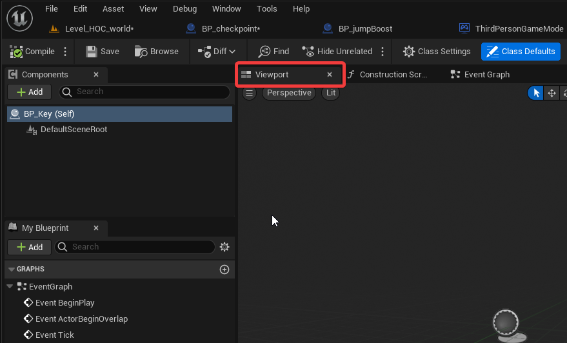
Figure 010 – Select the Viewport tab of the key Blueprint.
- The first piece we will add is a Collision Sphere Component. The collision sphere component will define the hit area for the key. When the player is in the hit area, it will activate the collision detection. Click the Add button at the top left corner of the interface, and search for “collision.” Then click the Sphere Collision option from the drop-down (Figure 011). You’ll see a wireframe sphere appear in the viewport.
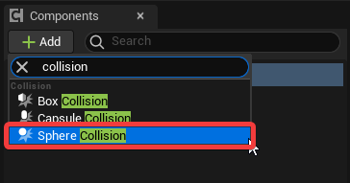
Figure 011 – Select a Sphere Collision.
- Then click on the DefaultSceneRoot in the components tab, this will ensure the next piece we add doesn’t become a child of the Sphere Collision (Figure 012).
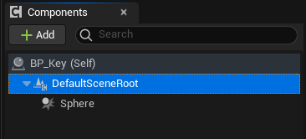
Figure 012 – Click on the DefaultSceneRoot when adding components.
Once again, click Add and search for “Static.” Be careful to choose the Static Mesh that is located at the bottom of the list (Figure 013).
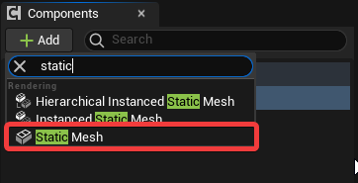
Figure 013 – Select the “Static Mesh” from the bottom of the list.
- Now select the Static Mesh in the Component panel. Navigate to the Details panel (located on the right-hand side of your screen) and find the Static Mesh section (Figure 014). Click the drop-down that says None, and search for “key”. Then choose the SM_key (Figure 015). You can move the key so it sits in the middle of the sphere if you would like.
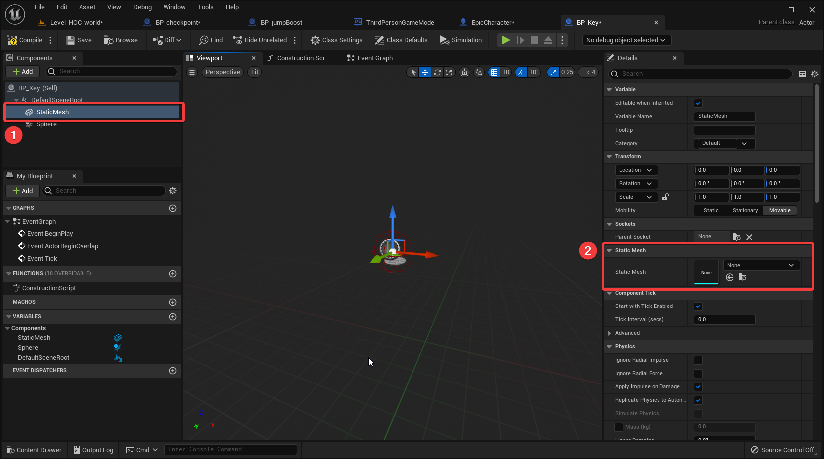
Figure 014 – Select SM_key as the static mesh.
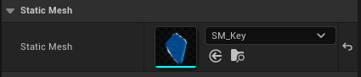
Figure 015 – Details Panel Once The Static Mesh Has Been Selected
- At this point, we should do some housekeeping. It’s ALWAYS a good idea to follow best practices that will aid you in the future. By naming our assets it will be easy to keep track of them. Select one in the content panel and press F2 to rename it. Rename the Sphere to Sphere_coll, because this is a collision sphere. Then rename the Static Mesh to SM_key, because it is a key (Figure 015).
🤖 TECHNICAL JARGON DEFINED
Static Mesh – In Unreal Engine a Static Mesh is 3D model made up of a set of polygons. Static Meshes are usually first created in 3rd party modelling tools like Maya or Blender and then imported into Unreal for use in level or character design.
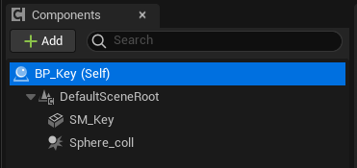
Figure 015 – The Component Hierarchy After Renaming
- Let’s Save our work by clicking the Save button at the top of the interface.

Building the Event Graph
- Click the Event Graph tab, this is where we will be writing the code to make this Blueprint work. You will see 3 nodes in the graph. These nodes were automatically added. Select all 3 and press the Delete key on the keyboard (Figure 016). We will not need them.
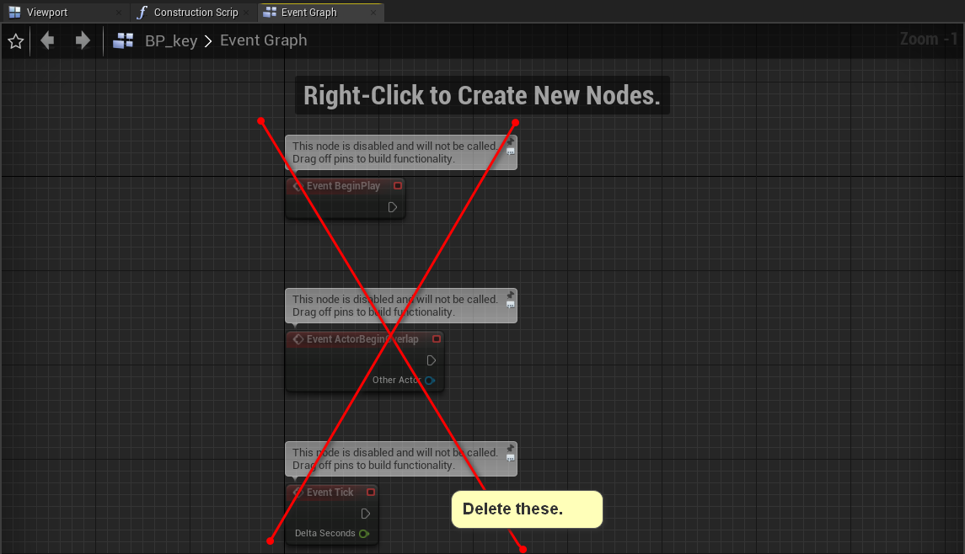
Figure 016 – Delete the unneeded default Blueprint event nodes.
- Create an event that triggers when the key is touched:
  - Select the Sphere_coll in the components tab.
  - Scroll to the bottom of the Details panel.
  - In the Events section click the green button in the Events section labeled On Component Begin Overlap (Figure 017).
This will create an Event node that will trigger when the Character touches the Sphere_coll. (In other words, this is what will execute when the player picks up the key.)
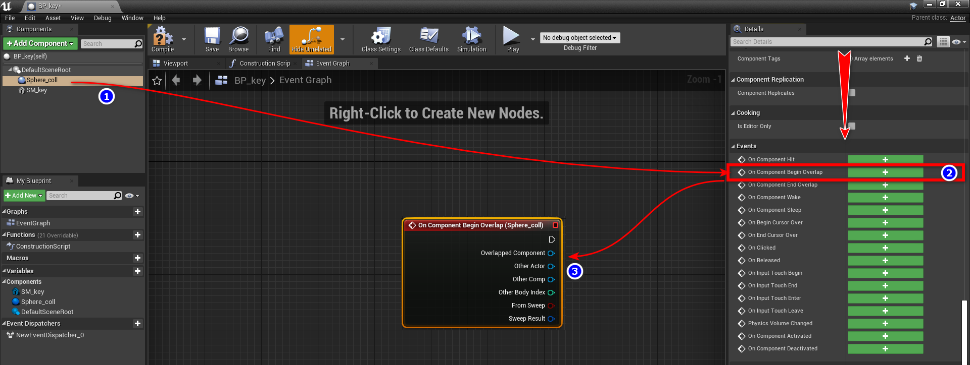
Figure 017 – Add the event to detect when the player touches the key.
🤝 PRO TIP FOR THE WIN
Navigating Blueprints - Use the scroll wheel to zoom in or out on a Blueprint. Click and drag the right mouse button in an empty space to move your view.
- We need to tell this Blueprint to talk to the game mode, to accomplish this we need to Cast to the game.
  - Begin by clicking and dragging a wire from the execution pin to the blank space in the Event Graph background.
  - Let go to bring up the Execution actions.
  - Type “cast to bp hour game” in the search field.
  - Select Cast to BP_HourOfCode_Game. This will create a new node (Figure 018).
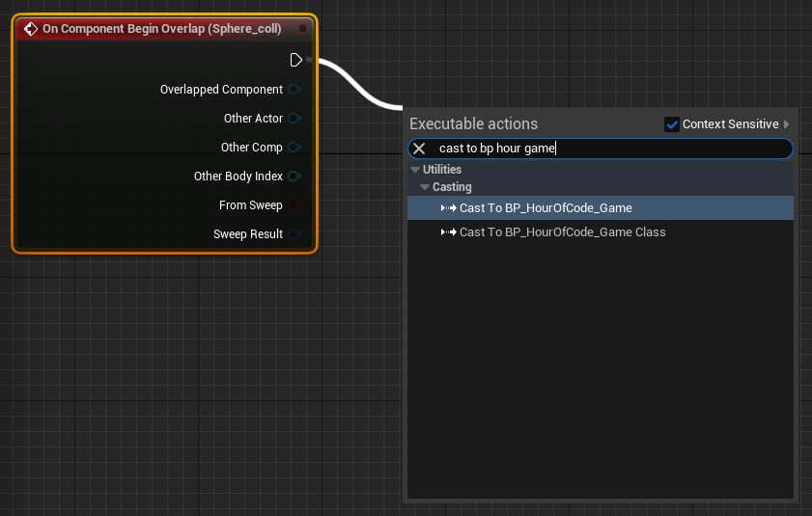
Figure 018 – The first action will be to communicate with the game mode.
🤖 TECHNICAL JARGON DEFINED
Game Mode – In Unreal Engine the Game Mode is a special object that keeps track of logic and rules that can be shared across multiple levels. The Game Mode is used to store things like the player’s score, what happens when a player dies, and the logic for pausing a game. In our game, the Game Mode is used to keep track of whether or not the player has the door key.
- Drag a wire from the Object pin and search for “get game mode”. Choose Get Game Mode, this will create another new node (Figure 019).
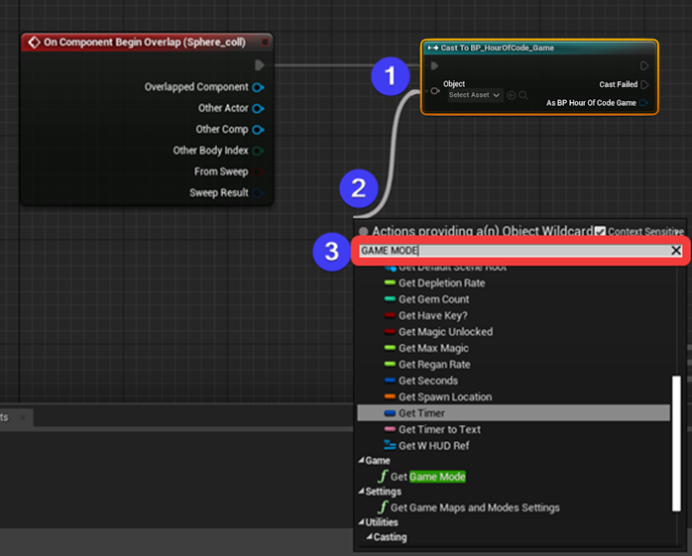
Figure 019 – Accessing the Game Mode from our Blueprint.
- Now that this Blueprint is talking to the game mode, the game mode needs to know what to do. We are going to tell the game mode to add a key to the character’s inventory. To achieve this, pull a wire from the bottom blue pin As BP Hour Of Code Game from the Cast to BP_HourOfCode_Game node and search “set have key.” Choose Set Have Key? (Figure 020)
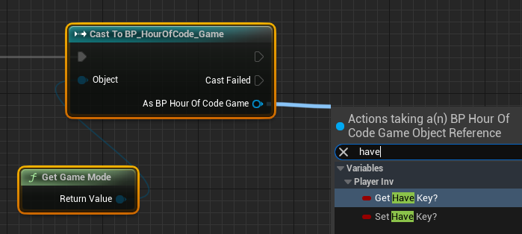
Figure 020 – Accessing the “Have Key?” Variable
- Connect the execution pin from Cast To BP_HourOfCode_Game to the SET node (Figure 021) and toggle the checkbox ON. We want to set this Boolean to true.
The HaveKey? variable represents the question: “Does the player have the key?”
We are setting the answer to yes (true) with this boolean node.
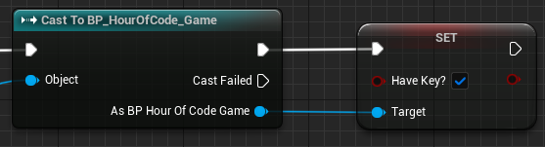
Figure 021 – Set the Game Mode’s “Have Key?” variable to true.
- Let’s add a sound so the player knows they have picked up the key. Pull off the execution pin from SET and search “play sound” and choose Play Sound 2D (Figure 022).
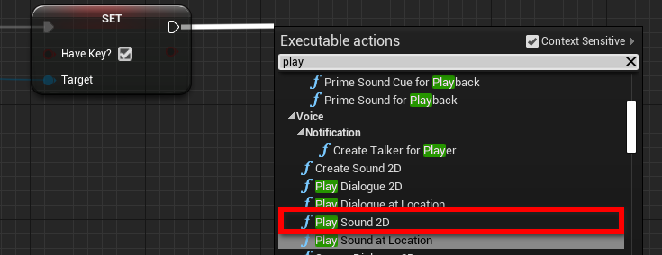
Figure 022 – Play a sound to signal that the key was picked up.
- We need to choose a sound to play. Click the Select Asset drop-down, search “key” and choose SFX_key (Figure 023).
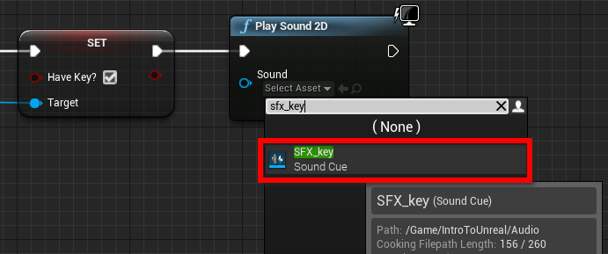
Figure 023 – Select the sound to play when the key is picked up.
- The last node we need to add will tell the Blueprint to destroy itself. After all, the character has touched the key to collect it, therefore it does not need to be in the level anymore. Drag a wire from the execution pin of Play Sound 2D and type “destroy actor”. Choose Destroy Actor (Figure 024).
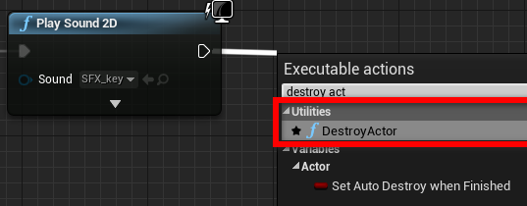
Figure 024 – Use Destroy Actor to remove the key from the game when it is collected.
- To complete this we will need to Compile the code and Save all the work we have completed. When you click the Compile button (top left) the “?” should change to a green checkmark. (Figure 006)
Take a deep breath and look over Figure 025 to cross-reference it with your work. Ensure that you are casting to the BP_HourOfCode_Game and that the checkbox in the Set node contains a checkmark.
If everything looks good be sure to select all the nodes, hit “c” on the keyboard, and add a comment explaining this section of code.
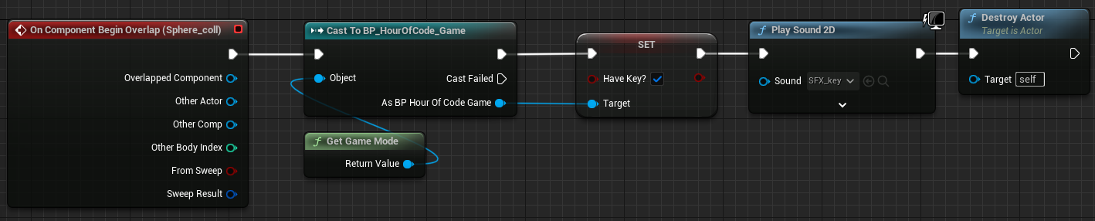
Figure 025 – Save and Compile your Blueprint.

Play Testing Your Blueprint
Now, it’s time to playtest your Blueprint.
Make sure you have compiled and saved your Blueprint and then click the X in the upper-right corner to close the Blueprint editor. (Make sure you are closing the window with the Blueprint editor, so you don’t accidentally close your entire project.)
Now, you should be back to your world editor. Click in the Viewport and press the number 5 to jump to camera bookmark 5. In the Content Browser, navigate to Content > Hour_of_Code > Blueprints. Drag a copy of your BP_key into your level next to the door on the final island. Press W to activate the Move gizmo. Drag the blue arrow up to position the key floating above the ground (Figure 026).
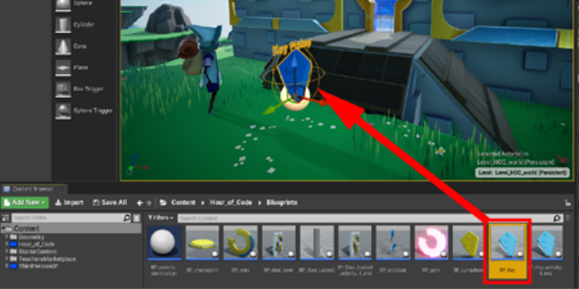
Figure 026 – Adding the key to your game for testing purposes.
Press the Play button to test your key.
To fully test your key, DO NOT walk over it as soon as you start playing the game. First, walk up to the door, you should see a message that tells the player “Key Needed” (Figure 027). This is because you have yet to pick up the key.
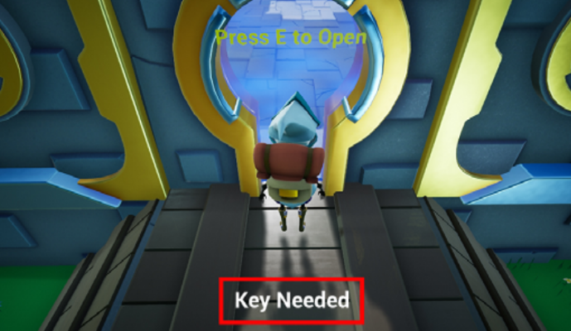
Figure 027 – The “Key Needed” message should appear when trying to open the door without the key.
Second, pick up the key. You should hear a metallic key sound, and the key will disappear.
NOTE: Be sure your speakers are working correctly.
Next, walk up to the door. The “Key Needed” message should NOT show up on the screen.
Last, press the E key on your keyboard and the door will open, and a key icon should show up on the bottom left-hand side of the screen. Don’t worry about this icon, it’s just a hint of what we will be covering in Activity 5.

Placing the Key and the Final Pick-up
Now that the door is open, we have one last task. We need to add the end goal. Inside the Blueprints folder, you will find BP_endGoal. Drag it into your level to the top of the ramp at the back of the fortress (Figure 028).
Remember to Save All your work.
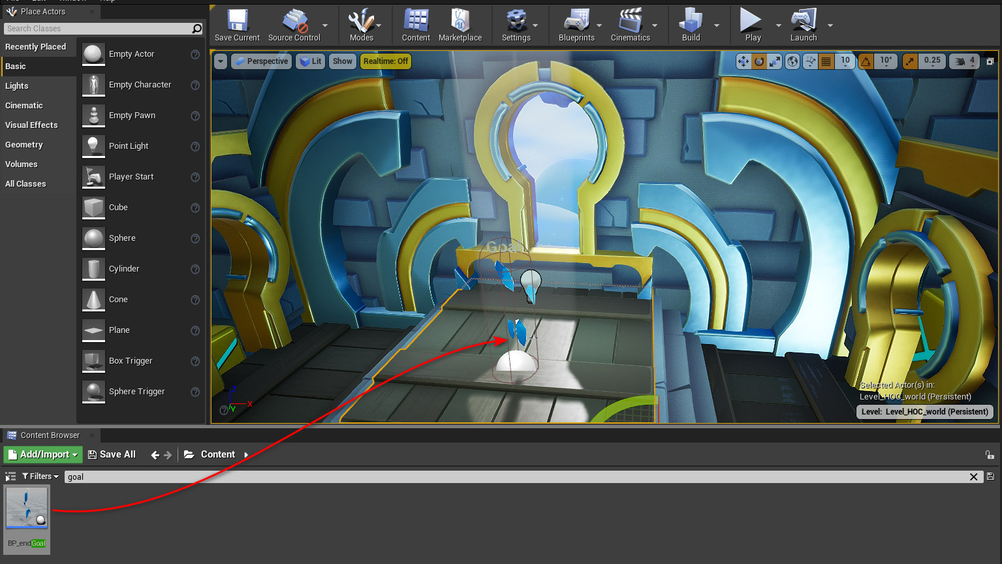
Figure 028 – Add the End Goal pick-up Inside the locked fortress.
You should now remove the test key you placed in front of the fortress and place it in a better location. We recommend the platform at the bookmarked position you can access by hitting 4 on your keyboard. (Figure 029) You may also wish to add some more coins throughout the game to help guide the player.
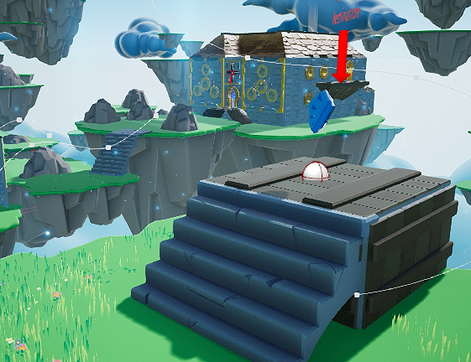
Figure 029 – This Is a Good Place To Hide The Key

Play Testing Your Game
With the goal in place, you should play test your game from beginning to end. You’ll notice that once you touch the end goal the player is rewarded with various stats, such as how many coins and gems they collected, in addition to how long it took to complete the level.
To play your game from the beginning, click the dropdown arrow on the Play button and select the Default Player Start option.
Now, clicking the Play button should start you at the beginning.
Watch your play testers play the level, but don’t tell them where to go. Observe where they get frustrated or where they get lost. Use these observations to improve your platform sequences to make the journey more fun.

Part Four Completed!
Well done!

What’s Next?
In the next activity we will cover how to make various sections of the heads-up display (HUD) visible. Both the key icon you saw earlier, and the end game screen are part of the HUD. We will also package the game so you can send it to other people to play or add it to your portfolio when looking for jobs.
🚀 Your Progress
 

Further Reading
- Official Blueprint Editor Reference
- Official Blueprint Flow Control Guide
- Official Description of a Static Mesh in Unreal
- Official Blueprint Class Creation Guide

